Penguins Radio Network 2023 Satellite Information.

The Pens audio this year will be provided via Premiere XDS receiver.

Source Premiere XDS receiver

Program: iHM Pittsburgh

Audio needs to be wired from the left channel of the audio port.

Audio is connected through the DB9 connector

Pin 6 +L Out

Pin 7 Ground

Pin 8 –L Out

\***UPDATED FOR NEWER XDS PRO SATELLITE AUDIO CONNECTION\***

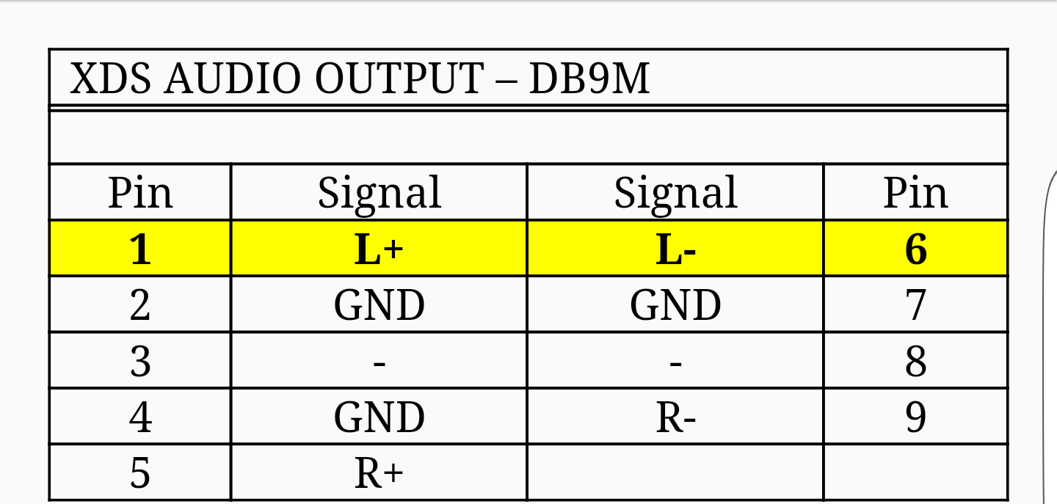

Relay assignments

IH2BSOS1            Start of Show

IH2BLOC1            Local Break

IH2BNET1            Network Break

IH2BID1               Legal ID

IH2BEOS1            End of Show

IH2BRJN1            Rejoin

Pinout for relays will be where you assign them. (location dependent)

Once you are connected and programmed you can call us in Pittsburgh for testing at 1-866-922-2874 or 412-253-3112 (Wayne).

If you have questions on satellite programming or connection please call the Premiere NOC at (800) 276-4431.